**Exercise**

1. Write a function that prints all the unique values from an array and the number of times each

value occurred. The main function takes a size of array as input and generates a random integer

array with name **“array1”**. Random number limit must be between 0 and 10. The ‘main’ function

calls a function with the name as “CountFrequency( )” that will find the occurrence of each value

in array.

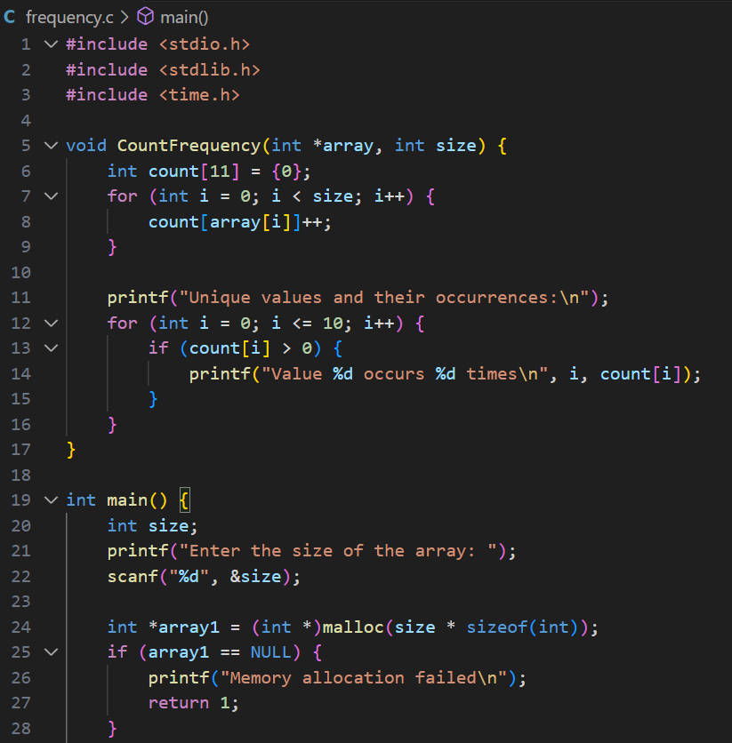

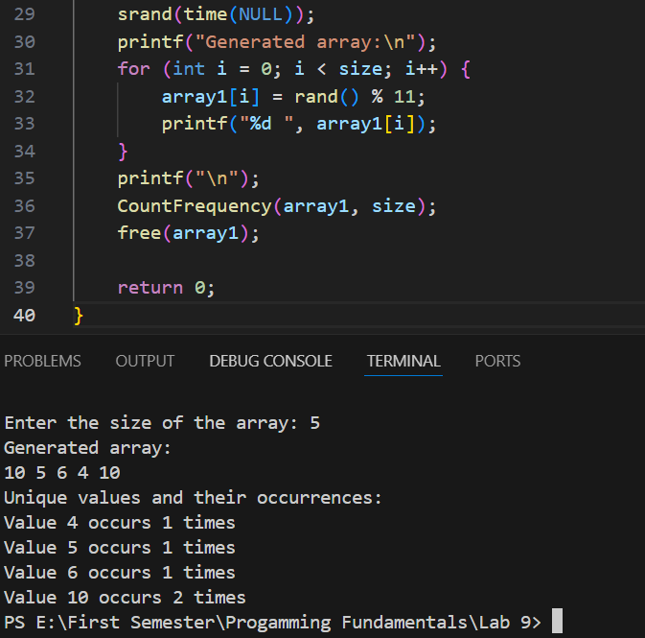

2. Salesflow is one of leading software house they are starting their recruitment process for three

different following positions: Associate Developer, Assistant Developer, Trainee Engineer. There

is a defined criterion for recruitment process: if candidate clears the test with 50 marks, he will

be selected for the post of trainee engineer; experience is not the required for this post. If

candidate secures 60 marks with at least one year of experience and 70 marks with at least 2

years of experience, then he/she will be selected as an assistant and associate developer,

respectively. Write a function that takes the test marks from user and ask for experience (if the

entered marks are x >=60). After that, function shows the assigned position.

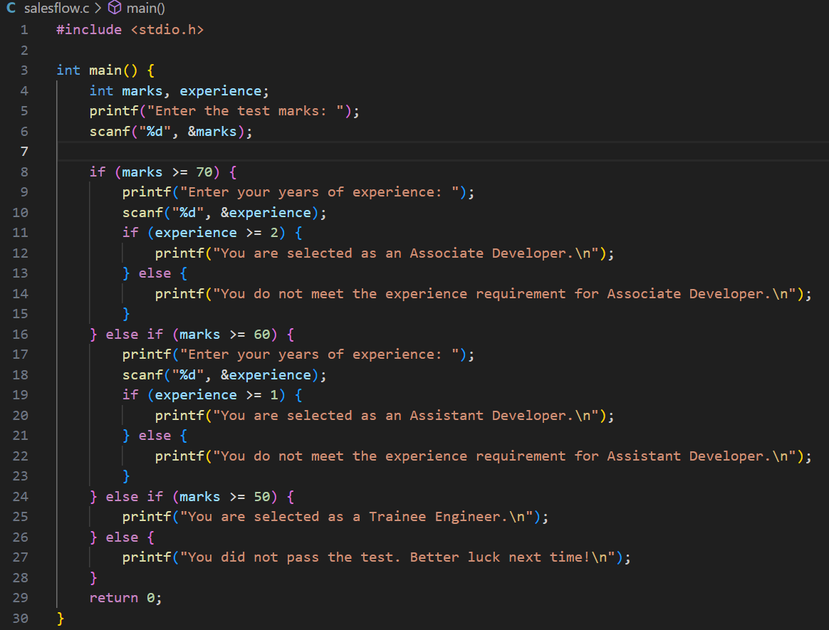

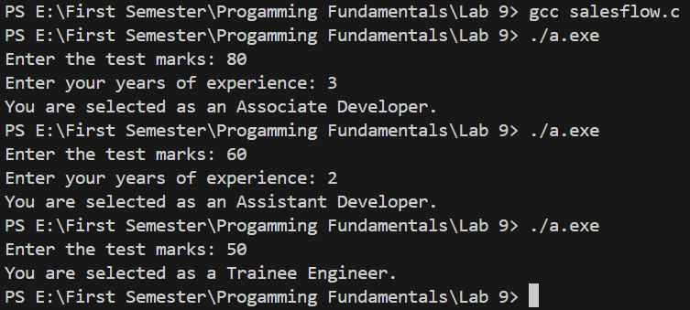

3. Write the program that calculate the volume by using following formula

𝑉 = 𝑎 2 ∗ 1 /3 ℎ,

by creating two separate functions. One of the functions with prototype “getData(int h, int a)”,

takes two inputs from user. The other function with prototype “volumeCal( )” calculates the

volume, and this function must be called from the first function “getData ( )”. The first function

must be called from the main function.

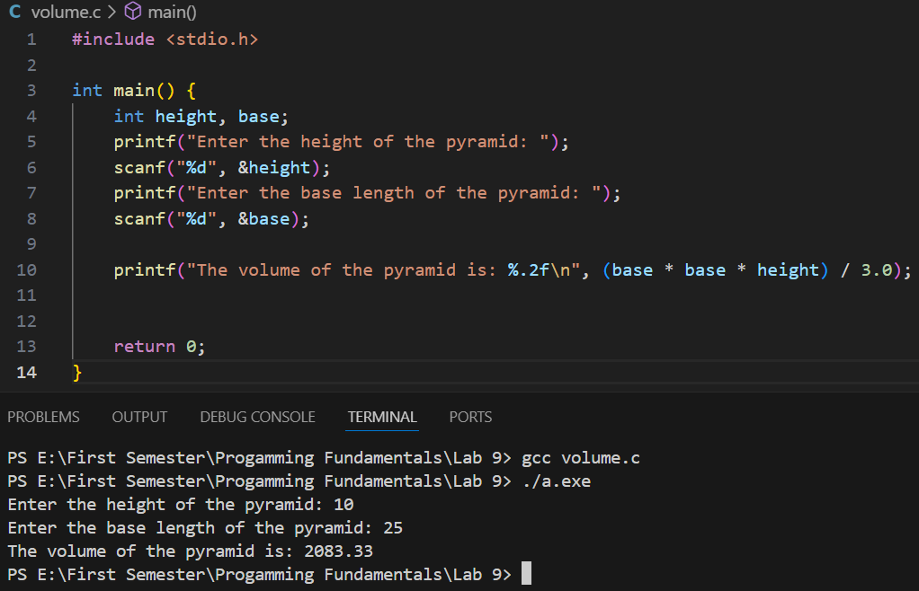

4. Write a program that takes a positive number with a fractional part and rounds it to two decimal

places. For example, 32.4851 would round to 32.49, and 32.4431 would round to 32.44.

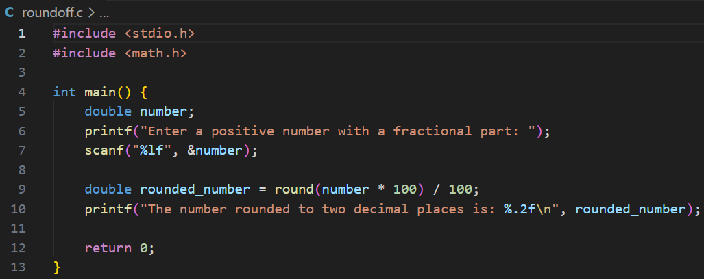

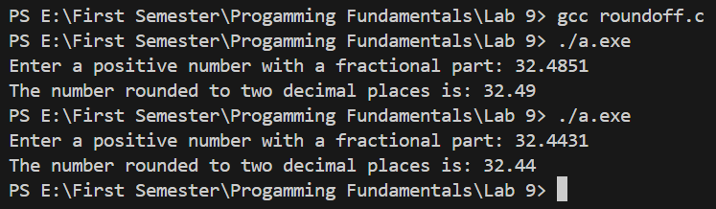

5. In shopping for a new house, you must consider several factors. In this problem the initial cost

of the house, the estimated annual fuel costs, and the annual tax rate are available. Write a

program that will determine the total cost of a house after a five-year period and run the

program for each of the following sets of data.

To calculate the house cost, add the initial cost to the fuel cost for five years, then add the

taxes for five years. Taxes for one year are computed by multiplying the tax rate by the initial

cost. Write and call a function that displays instructions to the program user.

